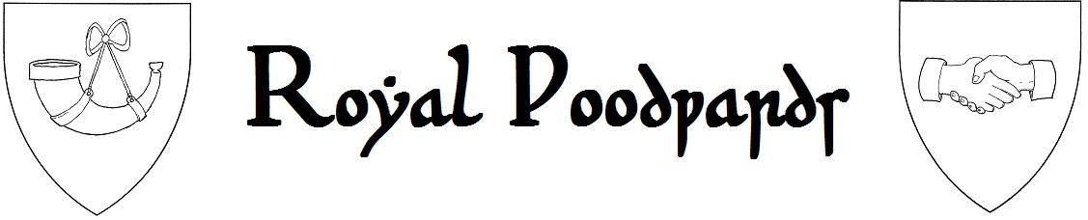
Order of St. John Gaulbert - Woodward Trial Application
The “Woodwards” are a sub group of men and women within the East Kingdom Royal Foresters Guild who are experienced at and excel at Forester Arts and Sciences and Service. Known as “The Order of St. John Gaulbert”, they are open to anyone whom has been a member of the guild for at least 90 days and has sworn the Foresters oath to become a member of the Royal Foresters Court, and has been promoted to the Rank of Forester or above. They are based on their medieval counterparts whom were typically forest law officials who would work in the Royal Forests at resource management. The term was synonymous with forester at various times but Woodwards dealt primarily with trees and lumber. While anyone can be a Forester, few can become a Woodward, and fewer yet wish to do so.
The Woodward applicants are selected annually or as applications are received. The yearly Woodward Trials typically take place at an SCA event but the trial may have been ongoing for months or years. Woodwards are typically involved with their personal challenge for great lengths of time and so often do not present themselves to the committee until they are satisfied with their work. The trial often involves a masterwork arts and sciences project or many lesser projects as well as acts of service such as guild organization, event stewarding and guild operation. From the time the application is received a minimum of one year will typically go by perhaps as many as five. Applicants submitting a masterwork should also submit several early works and be able to show how their master work differs significantly. Applicants submitting multiple works must show how they are very different or how they all work in conjunction with one another, for example, the many items a Forester needs on his/her person. Those choosing service may combine it with arts and sciences or may elect to run five successive forester themed SCA events or a combination of SCA events and forester private events. Guild administration and chapter formation also count towards the Woodward Challenges. Any applicant who applies and who spends one year as a Keeper of the Forest for a local group, and then spends two years as a Warden either in Canada or the United States and then Finally spends an additional two years as Warden of the East will be considered to have faced the Woodward Challenge.
The application paperwork of the Woodward Trials is just a formality. The majority of the trial will be done on the applicants own time, so similar to the Forester application it serves only as a membership file. The Woodwards are similar to the SCA merit orders of laurel and pelecan with the exception of an application process which guarantees no political process for recognition. It is demanding though, and it involves great deal of personal sacrifice that some SCA members will be hesitant to embrace.
Applicants that pass the Woodward Trials but whom do not accept the offer to join the group are still respected and honored members of the guild and they may continue through the various guild ranks and are eligible to be selected for office and other orders of merit; they are not considered “Woodwards” however. Only those with a willingness to complete their initiation ritual and abide by the “Woodwards Oath” will be granted Woodward status. The expectations and inner workings of the Woodwards will be explained in full to successful applicants after their trial in a special ceremony where Royal Woodwards are initiated into the Order of St. John Gaulbert. Woodward applicants may refuse the offer to become a Royal Woodward at any point before the initiation ritual. All applicants will be given a time of reflection before the initiation ritual to make their final decision. At this time they will learn the Woodwards Oath and recite it as part of their initiation. Once initiated, the applicant becomes a Woodward for life and no power or circumstance can relieve them of their life long obligations to their Brother and Sister Woodwards.
To accept a position on the Woodward Trials applicants must have ‘minimum’ the following items;
Clothing | Forester Gear
Period leather shoes or boots | Hunting Horn
Cotton/linen/merino wool undershirt
Wool/linen tunic/cotte/ shirt/ dress
Wool linen split hoes/ joined hoes/pants
Double layer wool hood/ lined hood

Information and questions. This form should be completed digitally and sent to the Warden of the East electronically. The Warden will contact and forward the applicant information to the Woodward selection committee whom will contact the applicant directly with further questions and to provide further information to the applicant.
Woodward Information and Questions Sheet
Name
SCA Name
Service Project
A&S Project
Brief explanation of your projects

This application will be stored in the applicant’s digital membership folder and is confidential. It is for internal EK Forester use only and will not be shared by the guild to any outside or governing SCA bodies including the Minister of Arts and Sciences. It is considered a private document of the guild and of the Order of St. Eustace and the Royal Woodwards of the East. It is to be considered a protected document with the information of the applicant destroyed upon the request of the applicant upon completion of the Woodward Trials.

